Lab 6:

DHCP:

DHCP (Dynamic Host Configuration Protocol) is a network management protocol used to dynamically assign an IP address to any device, or node, on a network so it can communicate using IP. DHCP automates and centrally manages these configurations rather than requiring network administrators to manually assign IP addresses to all network devices.

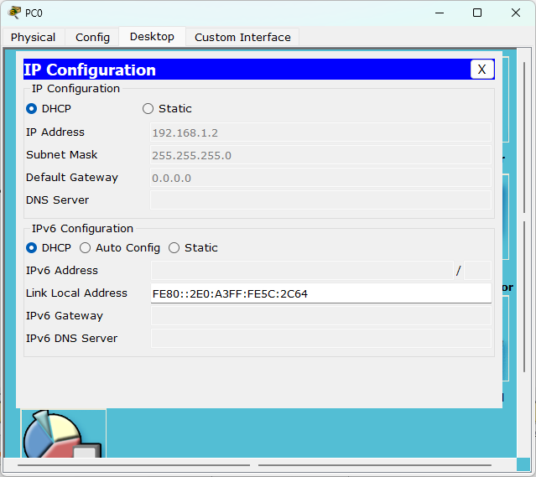

Static Routing:

It is a process in which we must manually add a route in a routing table. It is used when we have very few devices to configure and when we know the route which probably never gets changed. It is easy to implement in a small network. No overheads are produced on router CPU. Bandwidth usage is not required between networks.